# Software Requirements Specification (SRS)

**Project DigiSafe**

**Team:** No. 2

**Authors:** Craig Valenti, Sophie Hoelzel, Julie Chou, Parthey Khanderia

**Customer:** Children aged 7-8 years old, parents, teachers

**Instructor:** ProfessorJames Daly

# **Introduction**

The program’s Software Requirements Specification (SRS) of our edutainment game DigiSafe incorporates the purpose, scope and functionality of the system. Each section is designed to form a general, collective understanding of the program for the user as well as the implementer. This will help break down critical requirements and expectations clearly.

The purpose of this software is to introduce children into the digital world and the Internet, and to give them important information on how to safely and confidently use digital media and the Internet as tools in everyday life to their benefit while staying safe and healthy. DigiSafe falls into the category of storyline adventure games where you have to answer questions correctly to solve quests and proceed. Using simplified and pictorial scenarios, the children are taught how to behave in certain situations and apply their new knowledge in questions afterward.

In the first part of the SRS, the scope of DigiSafe is broken down into 8 topics that prepare children for entering the digital world. Definitions and abbreviations are provided to have a common understanding of game-specific vocabulary. The paragraph about the organization of the SRS gives the reader an impression of how the remaining content is structured.

In the second part of the SRS, critical information on the product that includes product perspective and product functions is provided. This should help to form an idea about how the program will perform when it is thoroughly implemented. The user characteristics will give an impression how the game requirements depend on the user’s expertise and skill set. The constraints, assumptions and dependencies help understanding why certain features are being chosen and why others are left out. Apportioning future requirements paints a picture in which direction the game could develop in the bigger picture.

In the third and fourth part the specific requirements and the modeling requirements are defined in detail to give an impression how the requirements and goals are conveyed to the actual software implementation. The modeling requirements portray the relationship between the different entities system and user’s input, whereas the specific requirements focus on technical specifications.

In the last part of this document, the prototype of DigiSafe is introduced and it is described which steps to take to use it. This will help getting a feeling of how the end product will perform.

## **1.1 Purpose**

The purpose of Software Requirements Specification is to layout the description, its parameters, and the goals of the software. The SRS forms the basis of the agreement between the developer and the clients.

The intended audience of the SRS is all stakeholders, namely the developers, project managers, and customers. The customers are teachers, parents, and executives of the education system.

## **1.2 Scope**

“DigiSafe is an interactive edutainment game that playfully teaches children basic concepts in digital safety and responsibility. Pictorial scenarios introduce the children to different situations on the internet and explain important guidelines. Children can then apply the new information in simple questions that pick up the prior depicted scenario. The game provides immediate positive and constructive feedback to ensure consistent motivation. Coherently, no scores or points will be awarded.”

DigiSafe will cover the most basic knowledge and guidelines that young children have to know when using the internet and digital media. The topics treated are “Digital Downtime, Etiquette, Health, Integrity, Responsibility, Literacy, Privacy and Security.”[8]

The game will teach them how to find things on the internet, how to access safe websites and how to create safe passwords. They will get introduced to how to store data, how to create a file or how to prevent neck problems, et cetera. Nevertheless, all the information provided is only an introduction to the whole topic. The game is not meant to be a substitute for the digital education of parents and teachers, but rather as an additional tool that makes it easier for children to comprehend the importance of the topics and the suggested approaches.

## **1.3 Definitions, acronyms, and abbreviations**

In order to have a common understanding of game-specific vocabulary, it is important to define the following terms:

“An *Avatar* is the main character of a game who finds themselves in different situations that require action.

A *Storyline* is a simplified exemplary situation that could happen in the real world.

A *PSG (pictorial scenario in the game’s storyline)* is a text passage of 8 - 10 sentences and a picture that altogether form a storyline to give information on a certain topic.

*Short Answer* fieldsprovide an interactive surface that exclusively checks syntax, not semantics.

*Multiple Choice* options provide up to four different choices of which only one is correct.

A *Question* can be answered by choosing a Multiple Choice option or typing in a short answer.

*Feedback* means a written notification that pops up after input by the user.

A *Lesson* consists of 10 quizzes; in total there are 8 lessons to be completed.” [3]

## **1.4 Organization**

The rest of the SRS will deal with the product perspective and product functions. The variety of interfaces, memory, and constraints will be discussed. Detailed information will be given on user characteristics, dependencies and assumptions made.

Unified Language Models will depict the structure of the software system and modeling requirements. Use Case Diagrams will be used to give an overview of dependencies between the system and stakeholders.

In the end, the prototype will be introduced and sample scenarios will give an impression of how the final product will behave and how the gameplay will feel.

# **Overall Description**

In this section, the content and functions of DigiSafe will be covered from the product’s perspective. Emphasis is given on the main goals that will be fulfilled by the different functions that our game has to offer. This section will also tackle the user characteristics and what can and will be expected from them.

Constraints will be pondered and assumptions about the user’s technical possessions and dependencies between them and our software will be discussed.

At the end of this section, future requirements will be defined that will be relevant after the prototype has been completed and implemented. At the moment the scope of these requirements is too tremendous to include all the discussed features, but they will significantly enhance the game experience in the future after its implementation.

# **Product Perspective**

Since only 45% of High Schools in America teach Computer Science as a part of the K12-Education system due to a lack of resources [4], DigiSafe can officiate as an introductory tool that facilitates children’s access to digital education. The first version of DigiSafe is designed to be part of a Computer Science or Exploring The Internet lesson in elementary school to make the class more interactive and practical. The content will be taught by means of sample scenarios with metaphorical examples. For schools where Computer Science is not taught in school, DigiSafe can be used by parents at home.

It is conceivable that with more content, more complex structures and in accordance with the Federal Department of Education, DigiSafe could become Certified Education Technology and replace the Computer Science classes in elementary school.

By initiating this education process at an early age, DigiSafe can help increase the demand for Computer Science classes and therefore help to develop the STEM field and making it more attractive for a bigger crowd. It can also motivate children to pursue extracurricular Computer Science activities in higher grades, even though it might not be mandatory or offered as a course in school.

Because DigiSafe will be designed as a component of the education system it will be completely free of any advertisement or commercial intention.

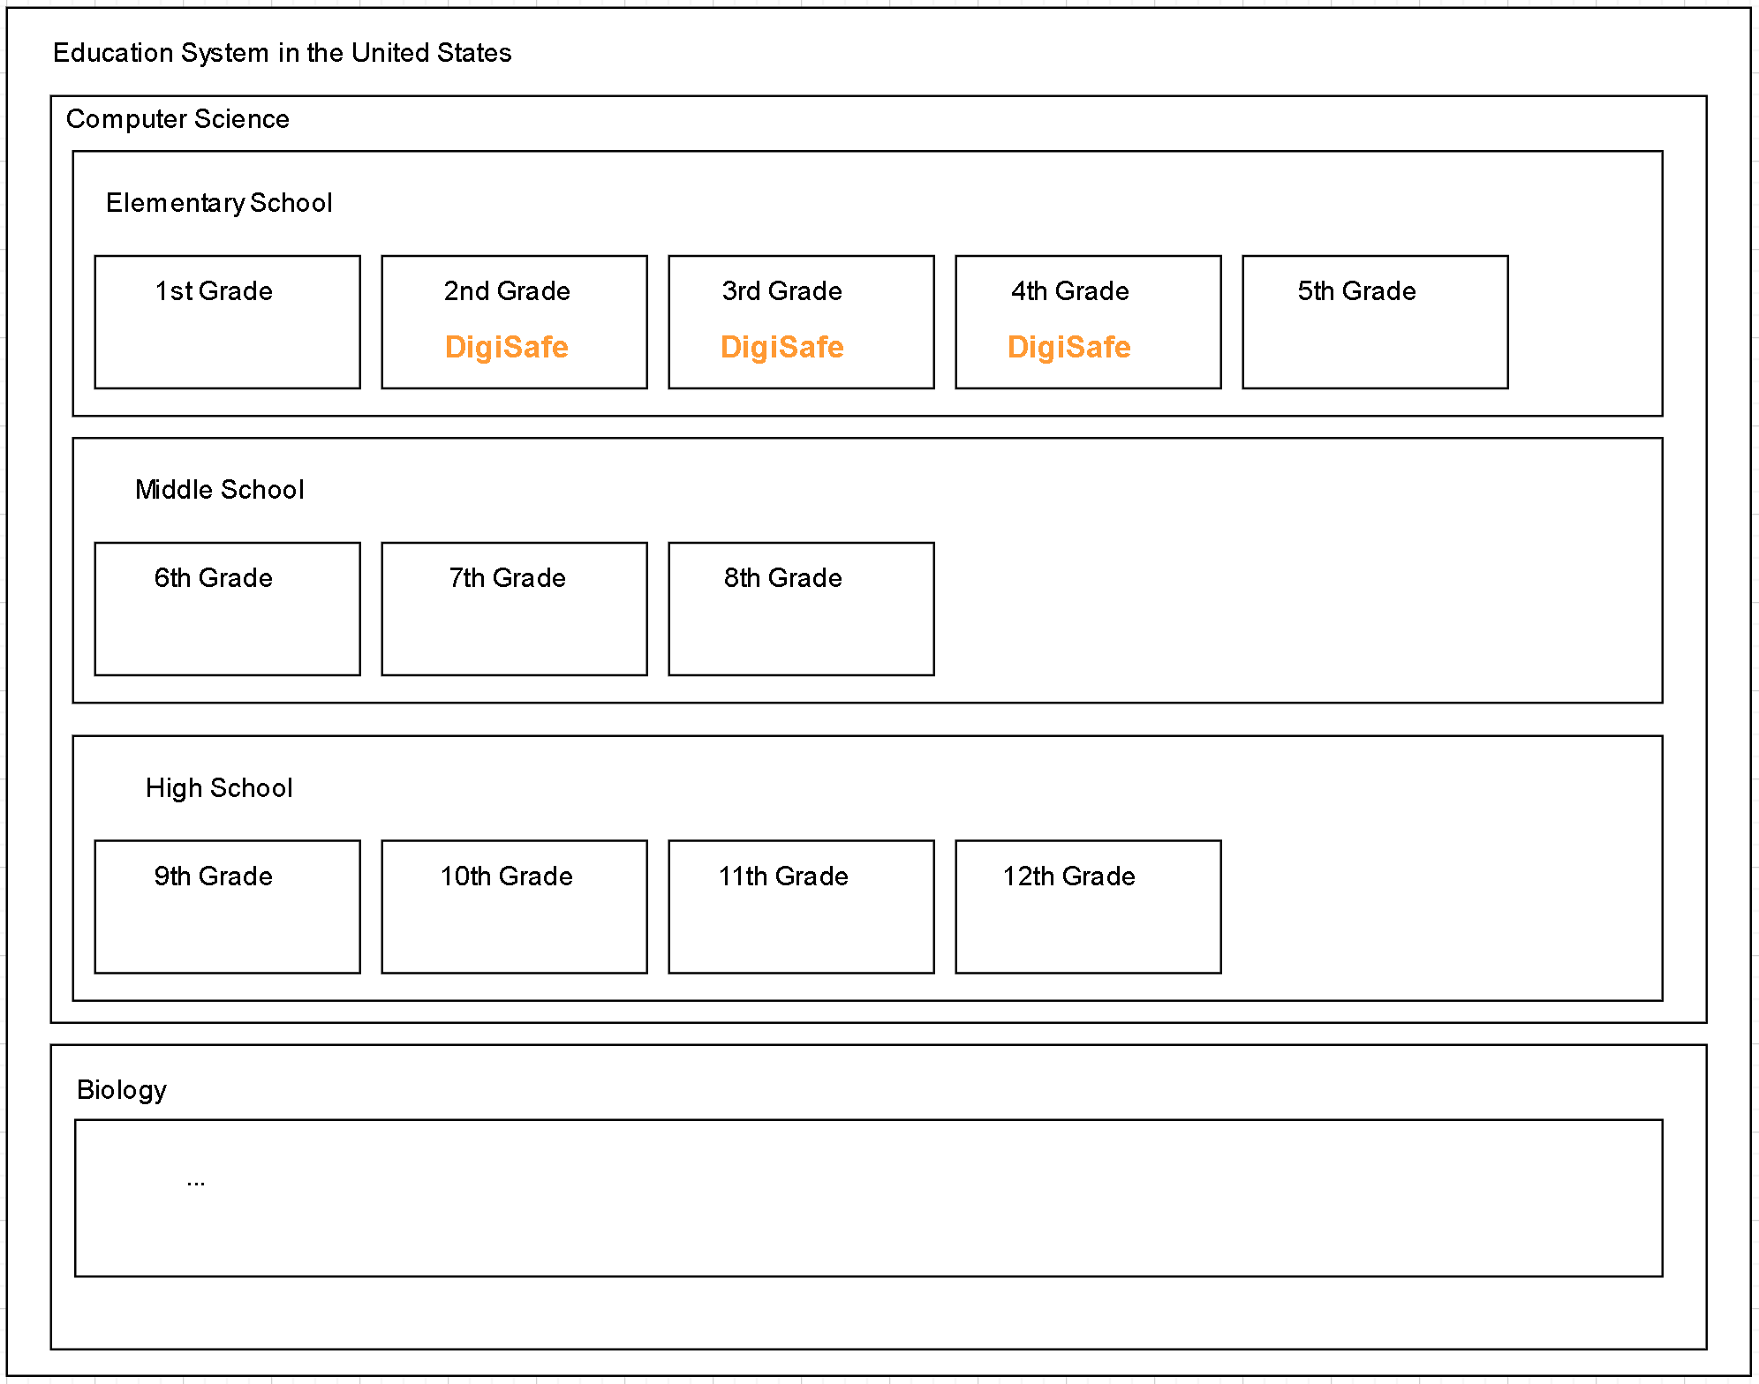

Fig. 1: Pictorial Representation DigiSafe in a bigger system

Each lesson that will be taught through represents a different topic of digital safety, they are all independent and can be performed at any given time. No hierarchical order between the lessons is given.

Since the game is web browser-based, the client acts as a localhost server. All verification is being done on the client, so no external server is required. The system functions independently, so there will be neither interfaces with other systems nor hardware interfaces. The only hardware needed to play this game will be a computer mouse, a keyboard and the desktop, which are all peripheral hardware.

The software interfaces are abstracted, because we are not using any JavaScript interfaces or languages for data structures. The only interface used is for HTML to create components like the quizzes which the user will see.

The user interface, however, will consist of Javascript which is the core of the design. It is important, that the User Interface is designed adequately for children therefore it should be intuitive and simple. To avoid overwhelming the user or putting epileptics in danger, there shouldn’t be too many moving things and colors at the same time. The avatar will be a crucial addition to the User Interface since it will help the user to connect to the material. It can be chosen out of a range of 5 different avatars. The chosen avatar will lead the user through the gameplay and the scenarios. There will be a frame for the avatar next to the frame for the storyline text which will be surrounded by a speech bubble to make the avatar seem like the narrator.

The process of choosing an avatar will also be the only site adaption operation that the user can perform. Keeping the order of the quizzes in a lessons facilitates the comparison of the student’s progress for an instructor.

In order to create communication between the user and the game, there will be communication interfaces. They will be implemented by creating interactive fields that require the user’s input. One kind of interactive field will be a form that requires a String input, the other kind uses events like on-mouse-click functions to select one correct answer out of a multiple choice catalog. Submission in these fields is sent to the client where they are verified. The only operations a user can make are therefore giving a text input and clicking on surfaces.

Even though the client keeps track of the game progress during a particular lesson by saving it to the website’s short term memory, the overall progress will not be saved in order to avoid the need to create login credentials. DigiSafe is supposed to be as accessible as possible, therefore any kind of registration would hinder the usability for children. Once the browser is refreshed or reloaded, all memories will be lost.

# **Product Functions**

DigiSafe will allow the user to go through a series of questions relating to internet security and digital safety. Users are allowed to select an avatar which will lead them through the game. It will present situations that children will encounter in the digital world and enables them to handle these situations, for example creating a safe password or protecting themselves from phishing. After the introduction of the topic, the child will be asked how to behave in a certain situation and can choose the solution from a multiple-choice catalog. Alternatively, there will be an interactive surface for short answers. For every possible input there will be constructive feedback on potential risks and implications. Thus the child can try out different solutions and learn without the pressure of getting the one “correct” solution. Once the child has selected the best appropriate solution, the “Next Question” button is activated. One lesson consists of 10 questions in the total of 8 lessons that can be completed at any time. DigiSafe can be used as an educational tool in elementary school or at home. Overall, the program is a tool designed to help children navigate the digital world with confidence.

This high-level goal diagram provides an overall context for what the user will be taught in the process of this game. The overall goal is an education in digital media and internet use with an entertaining component to enhance the learning experience and increase user loyalty. This main high-level goal is split up in 8 objectives, that describe the topics of which the goal consists. Each objective is broken down into the focus of the lessons, a more detailed view on what the user will be taught.

The main idea of this diagram is to deliver a clearer idea of how DigiSafe achieves the edutainment goal by giving an idea of the lesson plan at the same time.

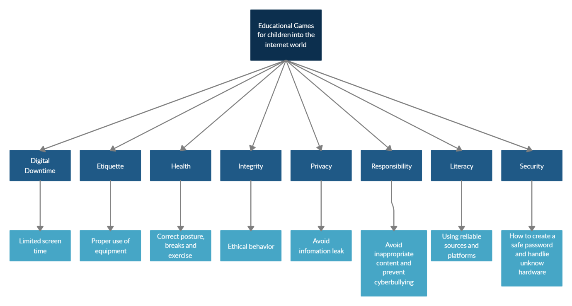

Fig. 2: High-Level-Goal Diagram

# **User Characteristics**

The targeted user group is children aged 7-8 years. At that age, “[c]hildren can not only make predictions about a text, they can justify their thinking. They can articulate the main idea of a text using summarising skills. They can discuss the main character and any character traits reading between the lines (inferring) to draw information.” [1] These skills will help them to read and comprehend the scenarios given in the lessons and convey their new knowledge to apply it in the following quiz. They are expected to be able to make a causal connection between the information they are given, the options and inputs they choose and the output determined by the design of the game. Even though the game gives sufficient background information and feedback, they should be able to comprehend the abstraction that is inherent in dealing with digital media. They will have to be able to connect simplified metaphors to the real application, e.g. a treasure chest and a key as an example for precious information and a password. The questions asked will be on a level that a child in that age range understands and that involves only a small amount of critical thinking.

As opposed to their literacy, their computational expertise can be low to almost non-existent, since they should always be advised and supervised by a parent or an instructor. Children should have some basic knowledge in how to operate a computer, e.g: how to turn on a computer and open a browser. They should be able to use a keyboard and a mouse as input devices.

# **Constraints**

The game is played on the browser, therefore the only way to access it is by using the input devices keyboard and mouse. The users can use their touchpad on their laptop or a mouse or tablets only since the website has not been configured for mobile device usage .

A constraint that can seriously affect the gameplay is a slow internet connection. The customer's machine can have any Operating System as long as it supports the appropriate Web browser. Internet connections need to be up to speed to use the browser. The game will have a screen resolution of 160x144, be restricted to a color palette of four shades of color. These will take up to 1MB or less. The game does not save user’s data, once the web browser is refreshed, Digisafe will start again from the beginning.

# **Assumptions and Dependencies**

It is assumed that every user has access to a personal computer or laptop of any kind as well as access to the Internet. The game operates on any given browser specified in section 4. It is also assumed that the browser user is using its latest updated version. For example, Chrome on Windows, Mac and Linux need to be at least 77.03865.90. [9]

# **Apportioning of Requirements**

Due to time and capacity constraints, there are some features that will prove useful in the future but couldn't be implemented in version 1 of our prototype. After negotiations with the customers they will be addressed in future releases.

In order to create a more coherent learning experience, being able to save progress will be important. On the home page, there will be a learning curve and a study plan that depict the progress already made and the topics. Being able to save the progress will significantly improve the flow of the game when using it as a day to day lesson tool. Another feature that will address the flow and accessibility will be a feature of going back to the last question or jumping back to the homepage at any time without losing progress.

Using machine learning, the game will recognize these topics where the user needs more practice, e.g. when he needed multiple attempts to get the correct answer and will automatically generate more questions from that pool.

In addition, there will be a stronger hierarchy in the lessons. Now every quiz is a subunit to its superior topic (see the figure in 2.2 Product Functions). In the future, there will be more subtopics and in general a greater amount of questions that go further into detail.

Adding more content can promote DigiSafe from an independent edutainment game to a whole educational program that accompanies students from an early age to higher grades where they can learn more about the internet and computer architecture in general targeting different age groups. At this point, a point system will help to keep track of the progress.

To make the game more personalized hence improving user loyalty, users will be allowed to modify their own unique avatar by adding tools, accessories, and child adequate weapons, e.g. a sword out of styrofoam, from a set of design elements. This will create a more unique game experience when they use the avatar to play in the minigames that will be a reward for completing a lesson in the future. The minigames will make the game more interactive and appealing. Choosing a username will also add to the personalized experience.

Furthermore, to improve the educational experience gained from playing DigiSafe, video explanations along with audio instead of plainly written text scenarios can help to maintain user attention and receptivity. This especially makes the game up suitable to an even younger target group, because younger children might not have sufficient reading skills.

# **Specific Requirements**

The user will have to choose between the following 5 avatars that each have possible design modifications:

1. Superhero
2. Scientist
3. Sloth
4. Astronaut
5. Mermaid

Also, the avatars will have different animations as a response to user input, which is specified below. As long as the user doesn’t change their avatar, the avatar’s design will remain the same throughout the game. This will also affect the graphic of the avatar in the minigame sequences in future versions of DigiSafe.

As soon as the user has chosen their avatar, the game will automatically take them to the next site, where they can pick one of the following 8 lessons:

1. Security
2. Digisafe will educate children on how to secure one’s data. Creating safe passwords and being responsible for [unacquainted](https://dict.leo.org/german-english/unacquainted) hard drives and USB sticks will be part of this lesson.
3. Digital Downtime
   1. Too much screen time may lead to obesity, behavioral issues, loss of social skills and or less time to play outside. Digisafe will guide children on how to use social media properly in a timely matter.
4. Etiquette
5. Etiquette is important for young children, not only to their friends and parents but also to tools as well. Learning through computers is efficient and convenient but one should never take advantage of it. Digisafe will teach children how to treat technologies with positive etiquette manners.
6. Health
7. Too much screen time can be harmful for children as well as adults. Knowledge in how to live a healthy life with technology is crucial. Therefore this lesson will instruct users in how to maintain good posture while using digital media. There will also be recommendations on the frequency of taking breaks and on how to determine the amount of exercise needed per week.
8. Integrity
9. Integrity is one of the fundamental values when using the internet. Being honest is important, in this lesson DigiSafe will guide the user on how to be ethical in the media.
10. Privacy
    1. In this lesson, the user will learn how to make accounts private, how to disable cookies and how to use the incognito mode in the browser as well as to which extent these measurements ensure privacy.
11. Responsibility
    1. This lesson is supposed to help prevent “cyberbullying, viewing (or posting) inappropriate content, or plagiarism” [6].
12. Literacy
    1. “[P]art of digital literacy is learning to search for content in an online space. Students have to query a search engine using keywords and navigate those results, including assessing the reliability of particular authors and websites.” [9] Users will be taught the necessary skills to perform these activities.

The chosen lesson will start and provide the user with the PSG, which means the PSG will...

1. ...Display the storyline with 8-10 sentences that explain the importance of the topic and explain how it should be handled.
   1. The language difficulty will be adjusted by the Leveling Resources Guide from Scholastic. [7]
   2. Next to the frame that displays the sentences of the PSG the avatar will be on a separate frame.
   3. The avatar will be depicted in the described situation.
2. ...Subsequently, pose the questions that the quiz contains.
   1. According to Leveling Resource Guide from Scholastic [7], the quizzes will be worded in second-grade reading level so that anyone above second grade will be able to understand them.
   2. It will be ensured that the possible MC answers are clearly distinguishable.
   3. Depending on the answer that the user puts in, the avatar will have a different animation.
      1. A wrong answer will display the avatar with a sad facial expression.
         1. A window will pop up in which it is described why the answer is wrong and what implications this could have in the real world. The user will get a hint on how to get the correct answer.
            1. Users can take the quiz until they get the correct answer, there is no trial limitation.
      2. A correct answer will display the avatar with a happy facial expression.

After the user has finished a lesson the screen will offer an overview of the remaining lessons which the user can choose. Alternatively, the user can go back to the main screen to select another avatar.

1. Users can restart any lesson and any quiz as many times as desired.

# **4 Modeling Requirements**

**4.1 Use Case Diagram**

When interacting with the game DigiSafe the user can select an avatar, select a lesson and put in an answer. Depending on the type of the question, the user can select a Multiple Choice Answer or type in a short text answer.

During a lesson, the game poses a question for each PSG provided. The answer that the user puts in is then verified by the game. 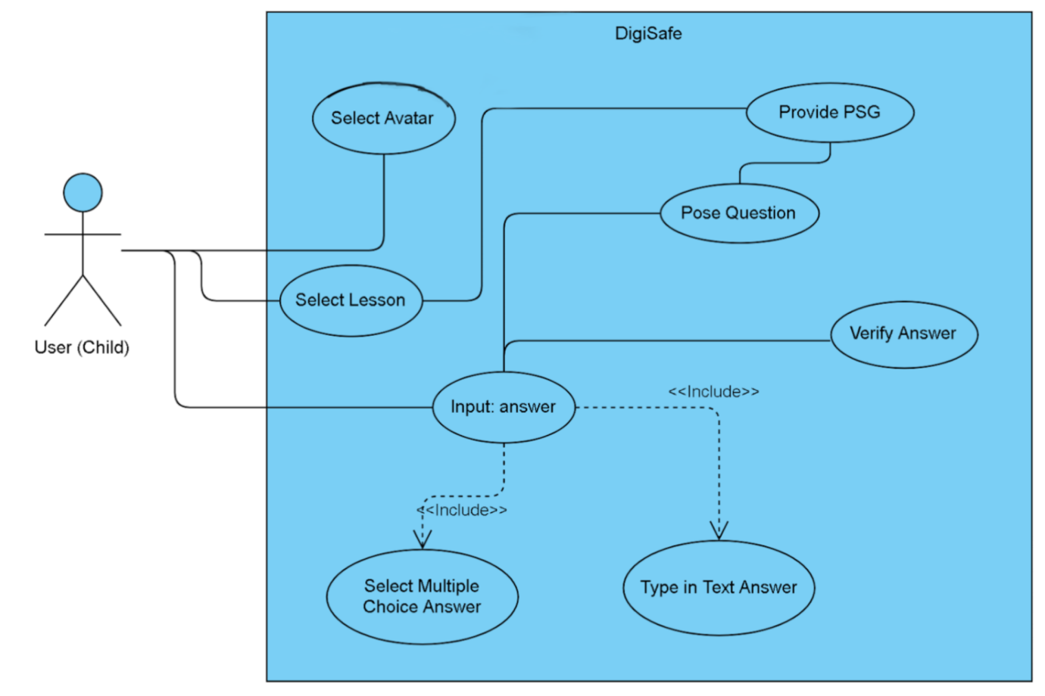

Fig. 3: DigiSafe Use Case Diagram

|  |  |
| --- | --- |
| Use Case Name: | Select Avatar |
| Actors: | User (Child) |
| Description: | The user can select an avatar of their choice. |
| Type: | Primary, Essential |
| Includes: | N/A |
| Extends: | N/A |
| Cross-refs: | N/A |
| Uses cases: | N/A |

|  |  |
| --- | --- |
| Use Case Name: | Select Lesson |
| Actors: | User (Child) |
| Description: | The user can select one lesson of their choice. |
| Type: | Primary, Essential |
| Includes: | N/A |
| Extends: | N/A |
| Cross-refs: | N/A |
| Uses cases: | N/A |

|  |  |
| --- | --- |
| Use Case Name: | Provide PSG |
| Actors: | N/A |
| Description: | During the selected lesson, the PSG will provide the necessary information in order to answer the question. In a passage of 8-10 sentences, the situation is explained to the user and they learn how to behave. |
| Type: | Secondary, Essential |
| Includes: | N/A |
| Extends: | N/A |
| Cross-refs: | N/A |
| Uses cases: | N/A |

|  |  |
| --- | --- |
| Use Case Name: | Pose Question |
| Actors: | N/A |
| Description: | After the situation was explained by the PSG, the system poses a question in how to behave in this |
| Type: | Secondary |
| Includes: | N/A |
| Extends: | N/A |
| Cross-refs: | N/A |
| Uses cases: | Provide PSG |

|  |  |
| --- | --- |
| Use Case Name: | Input: answer |
| Actors: | User (Child) |
| Description: | The user answers the question posed by the game. |
| Type: | Secondary, Essential |
| Includes: | Select Multiple Choice Answer, Type in Text Answer |
| Extends: | N/A |
| Cross-refs: | N/A |
| Uses cases: | Select Multiple Choice Answer, Type in Text Answer |

|  |  |
| --- | --- |
| Use Case Name: | Select Multiple Choice Answer |
| Actors: | User (Child) |
| Description: | The user picks their answer from a multiple-choice catalog. |
| Type: | Secondary, Essential |
| Includes: | N/A |
| Extends: | N/A |
| Cross-refs: | Input: answer |
| Uses cases: | N/A |

|  |  |
| --- | --- |
| Use Case Name: | Type in text answer |
| Actors: | User (Child) |
| Description: | The user types in their text answer to the question posed. |
| Type: | Secondary, Essential |
| Includes: | N/A |
| Extends: | N/A |
| Cross-refs: | Input: Answer |
| Uses cases: | N/A |

|  |  |
| --- | --- |
| Use Case Name: | Verify answer |
| Actors: | N/A |
| Description: | System checks whether the answer put in is correct or incorrect. |
| Type: | Secondary, Essential |
| Includes: | N/A |
| Extends: | N/A |
| Cross-refs: | N/A |
| Uses cases: | Input: answer |

**4.2 Sequence Diagram**

This diagram shows different scenarios that will occur while using Digisafe. The first scenario will bring the user directly to choose an Avatar. The user will pick one from the selection of 5 different avatars. There is only one outcome that can occur in the scenarios which is to go forward to pick a lesson.

The second scenario will be to pick a lesson. There will be 8 lessons for the user to pick from. This scenario will also have only one outcome. Users will pick one out of the 8 lessons and go forward to take quiz.

The third and the last scenario will be where the user can watch PSG and take a quiz consisting of 10 questions. There will be two possible outcomes that can occur in this scenario. The user can either go back to pick another lesson or go back to change the avatar and keep playing the game.

Fig. 4: Sequence Diagram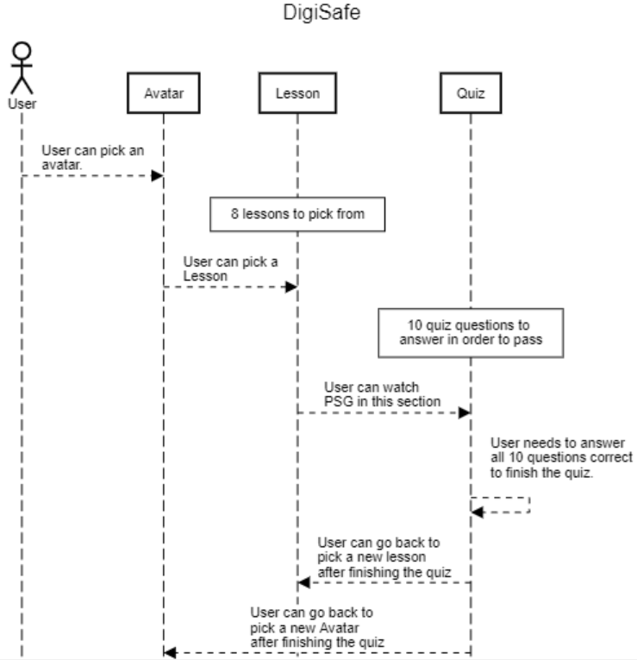

**4.3 State Diagram**

Below is the state diagram for DigiSafe. Each state is represented by a circle and the transactions made from each state are represented by arrows. All the states are either waiting for user input or idle. At first, the computer will be idle in the “Game(idle)” state.This is the homepage where the user will need to select an avatar for the game to proceed to the ”Avatar Selected” state. The user will then be able to select a lesson, which brings the game to the “Lesson Selected - PSG provided - Questions provided” state. After entering the state, the PSGs will be provided without any user input and sequentially the questions will be posed to the user. The user will watch all PSGs and answer all questions which brings the game to the “Take Quiz” state. In this state, the user will have to answer 10 questions in either multiple choice or text format. After taking the quiz the user will proceed to an idle state - “Pass the Quiz(idle)”. Here the user input will be verified by the game and the game can only transition to another state once the user has passed the quiz for the current lesson. From this state, the user can go back to select another avatar in the “Game(idle)” state. Alternatively, another lesson can be selected by going back to the “Avatar Selected” state.

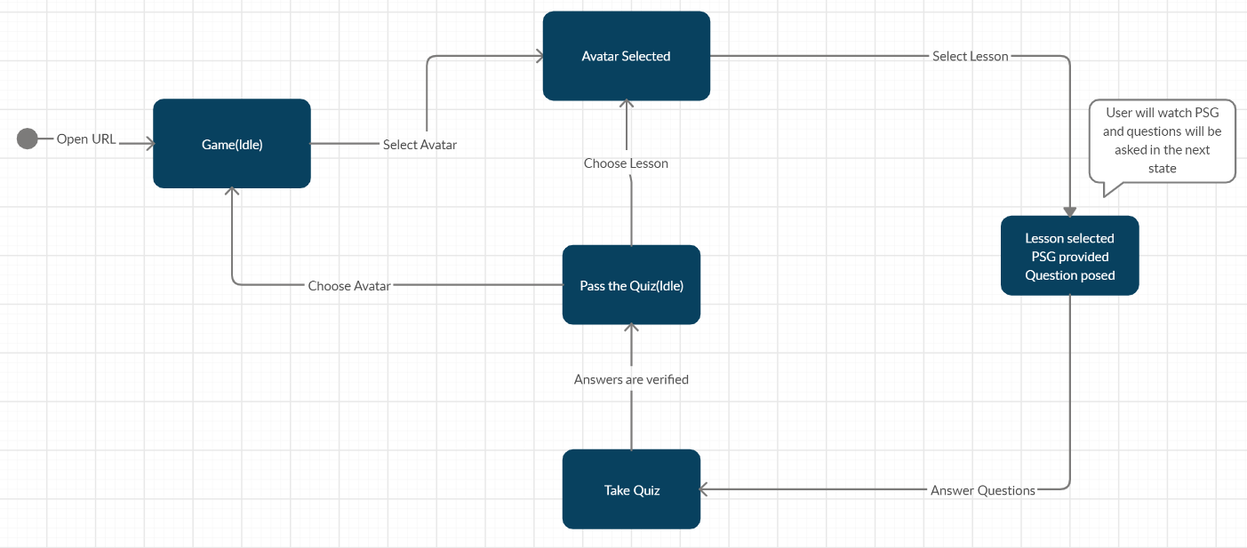

Fig. 5: State Diagram

**4.4.1 Class Diagram**

The class diagram depicts the software structure of DigiSafe. The main class is “Game” which has 1 to 5 avatars, represented by the “Avatar” class. Also, “Game” has 1 to 8 lessons which are represented by the “Lesson” class. Each lesson consists of 1 quiz. More detailed descriptions about the attributes and functions that each class offers can be found in the data dictionary below.

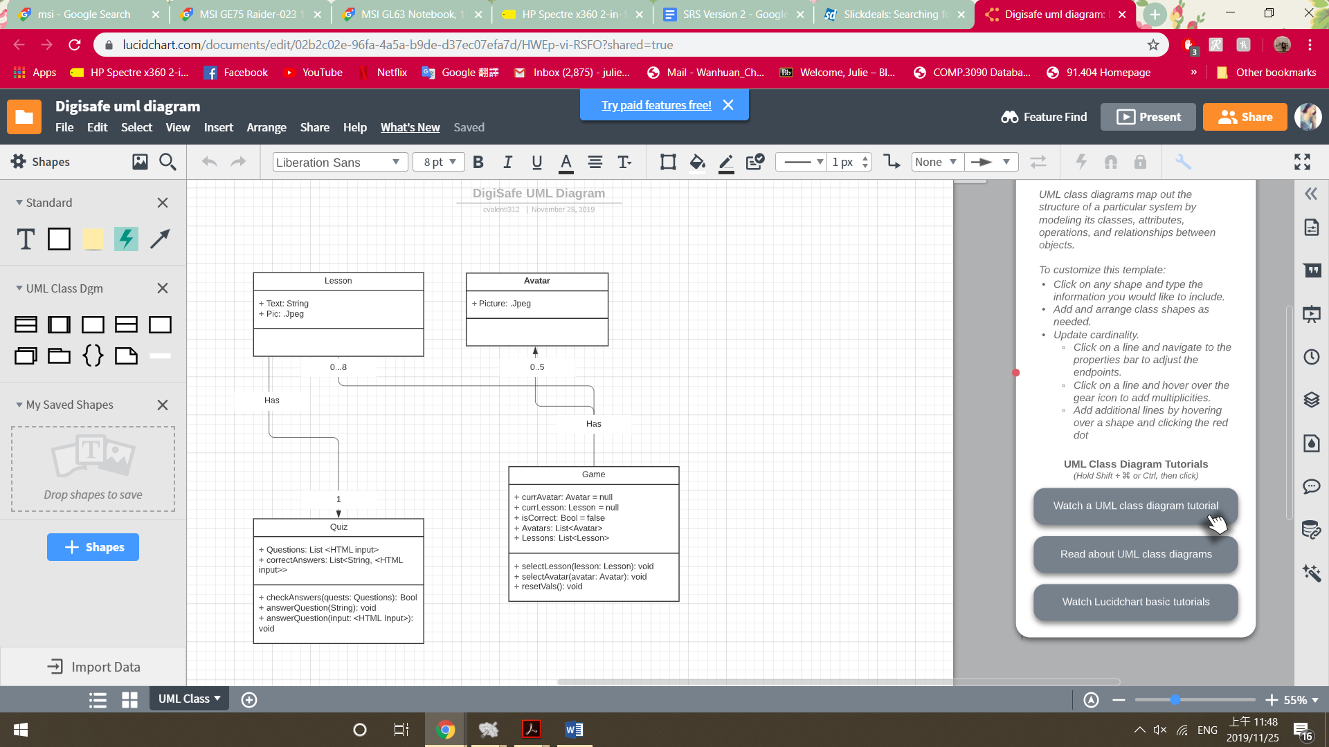

Fig. 6: Class Diagram

**4.4.2 Data Dictionary**

|  |  |  |
| --- | --- | --- |
| **Element Name** | | **Description** |
| Avatar | | User chooses an avatar |
| Attributes | + Picture: .Jpeg | Selectable pictures of avatar |
| Operations | N/A | N/A |
| Relationships | Each Game has an associated Avatar | |
| UML Extensions | N/A | |

|  |  |  |
| --- | --- | --- |
| **Element Name** | | **Description** |
| Lesson | | Our Lesson class only comprises of two attributes. For each Lesson, there exists associated text and one or more pictures to describe the lesson. |
| Attributes | + Text: String | Associated text of a lesson |
|  | + Pics: List<.Jpeg> | A list of one or more pictures to describe the lesson. |
| Operations | N/A | N/A |
| Relationships | Each Lesson has an associated Quiz. | |
| UML Extensions | N/A | |

|  |  |  |
| --- | --- | --- |
| **Element Name** | | **Description** |
| Quiz | | Users are to take a quiz after lessons, quiz contains multiple choice questions where users can input their answer by typing in text or select a choice. |
| Attributes | + Questions: List<HTML input> | Questions are a list of HTML input elements. |
|  | + correctAnswers: List<Regex, HTML Input> | A list containing all correct multiple choice answers and Regex for verifying short-answer questions. |
| Operations | + checkAnswers(quests: List<HTML input>): Bool | Checks the user-inputted answers for completion and correctness. |
|  | + answerQuestion(String): void | User inputs a string to answer a question |
|  | + answerQuestion(input: <HTML Input>): void | User selects an HTML input to answer a question. |
| Relationships | N/A | |
| UML Extensions | N/A | |

|  |  |  |
| --- | --- | --- |
| **Element Name** | | **Description** |
| Game | | Element that holds both operations to avatar and lesson. |
| Attributes | + currAvatar: Avatar = null | The current avatar selected. |
|  | + currLesson: Lesson = null | The current lesson selected. |
|  | + isCorrect: Bool = false | isCorrect is set to true when checkAnswers() returns true. |
|  | + Avatars: List<Avatar> | List of available Avatars. |
|  | + Lessons: List<Lesson> | List of available Lessons. |
| Operations | + selectLesson(lesson: Lesson): void | Select a Lesson from the list of Lessons |
|  | + selectAvatar(avatar: Avatar): void | Select an Avatar from the list of Avatars. |
|  | +resetVals(): void | Resets currAvatar and currLesson to null when user is finished with lesson or exits game. |
| Relationships | Each Game has a current Lesson. | |
| UML Extensions | N/A | |

# **5 Prototype**

Our prototype will provide the user with the possibility to choose an avatar. Then, they can select a lesson, which leads to the scenario where the user can read the content and explanations. In the next step, they can answer questions to test the newly gained knowledge.

# **5.1 How to Run Prototype**

The computer with a web browser and access to the internet will be the basis to run the prototype. The system configuration is 1GB RAM, 2.00 GHz processor, 10 GB storage and a compatible mouse and keyboard. Along with the suitable operations which explained in detail under ***3 Specific Requirements***. Chrome 78 is also required to run the program for the best experience in DigiSafe. It is accessible via the URL: *h*[*ttps://stark-scrubland-66787.herokuapp.com/*](https://stark-scrubland-66787.herokuapp.com/)*.*

**5.2** **Sample Scenarios**

One of the most common applications will be a computer science or exploring the internet class in elementary school. For example, instead of just discussing with the class how and why to create strong passwords, the teacher tells the students to go to the DigiSafe Website to introduce them to the topic of security.

The prototype is available via the following URL: *h*[*ttps://stark-scrubland-66787.herokuapp.com/*](https://stark-scrubland-66787.herokuapp.com/)*.*

The game will open the Avatar selection page. 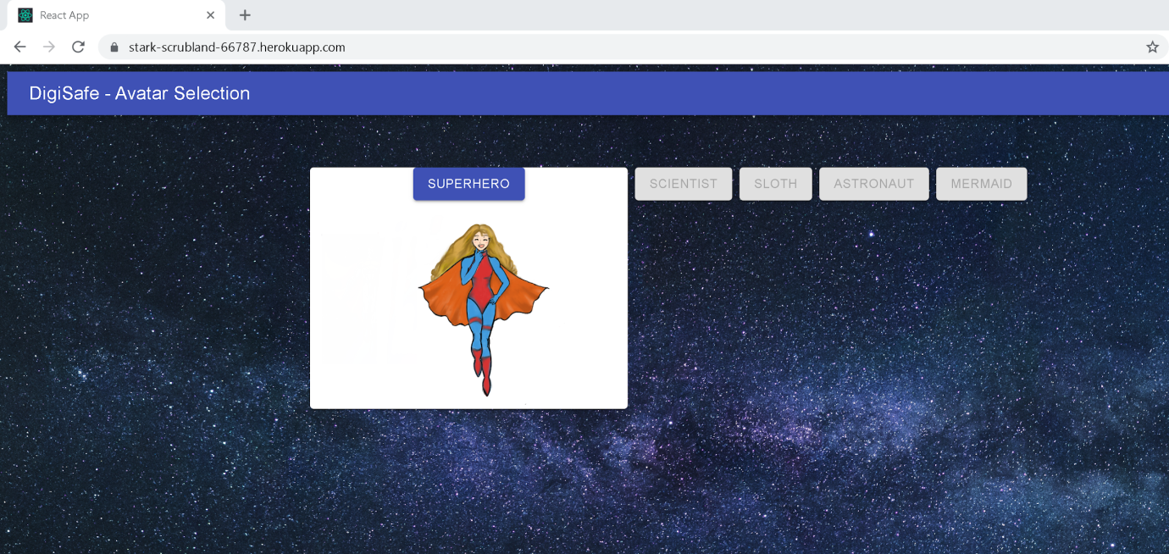

The selection is carried out by clicking on the avatar’s name, in this case, the child chooses the Superhero.

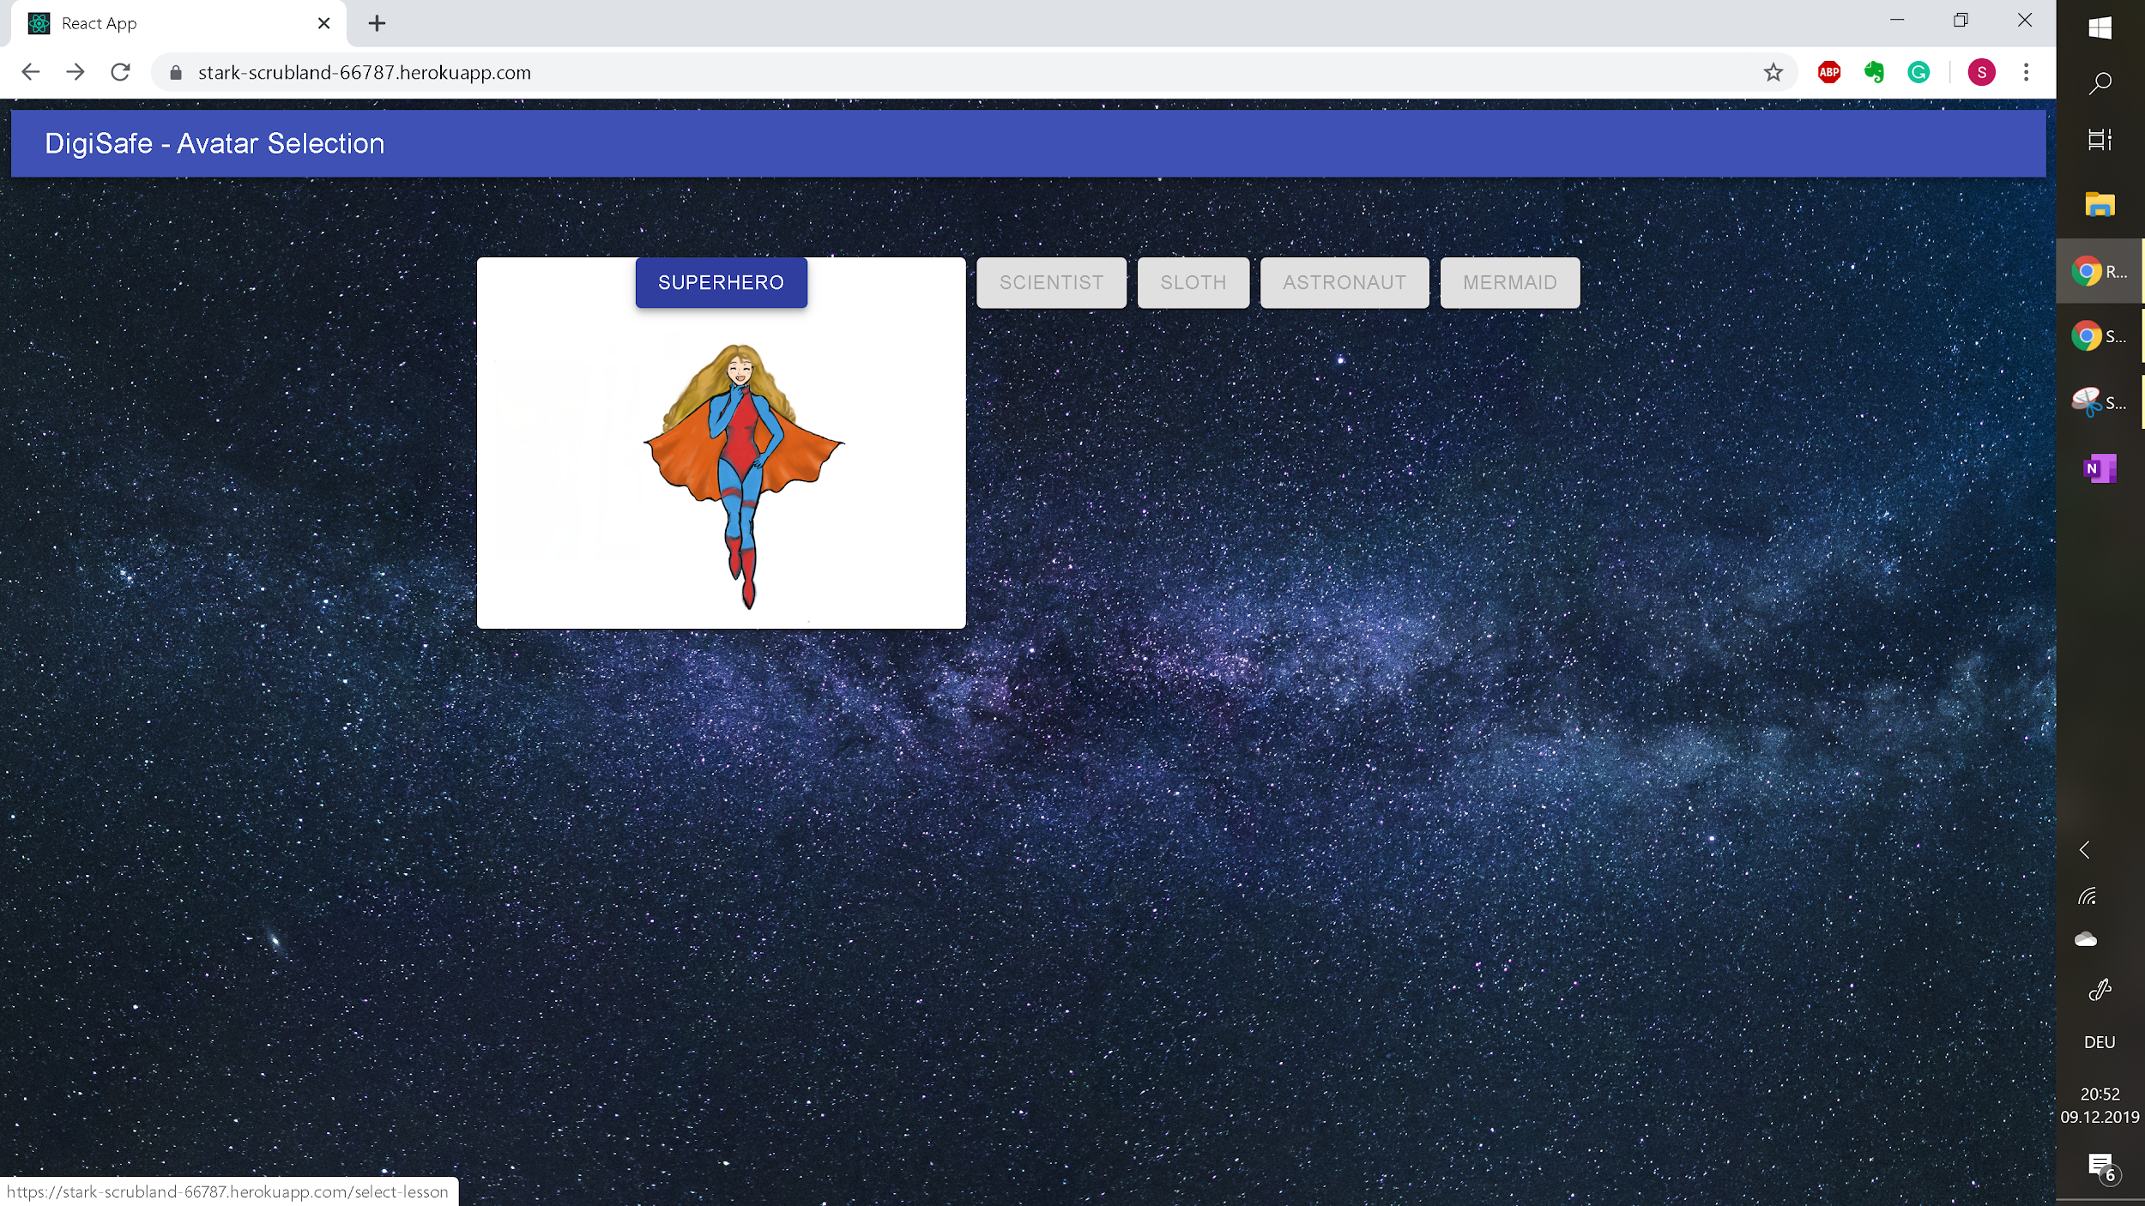

This will take the child to the Select Lesson site. Here, the procedure is the same. Clicking on the name of the lesson takes the user to the content of the said lesson, in this case the lesson is about Digital Security.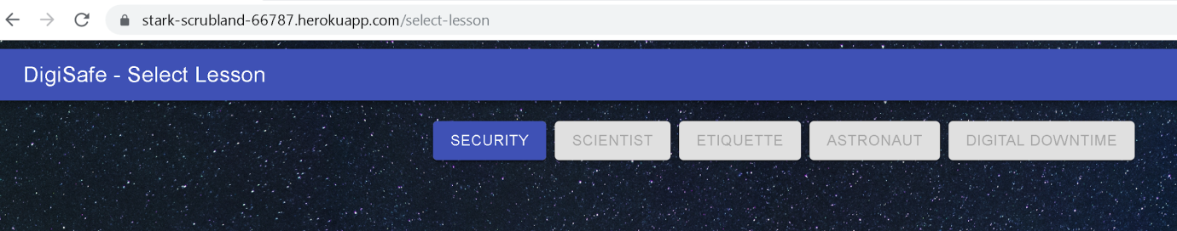

Now, the first pictorial scenario appears with the avatar in the depicted situation on the left. The avatar’s story is displayed on the right to make a transition between a relatable example and the theory that the user will be taught. On the bottom of the page is the narration that draws a connection between the scenario the Superhero finds herself in and the digital world. It is explained why Digital Security is important and which key elements that the user should be aware of.

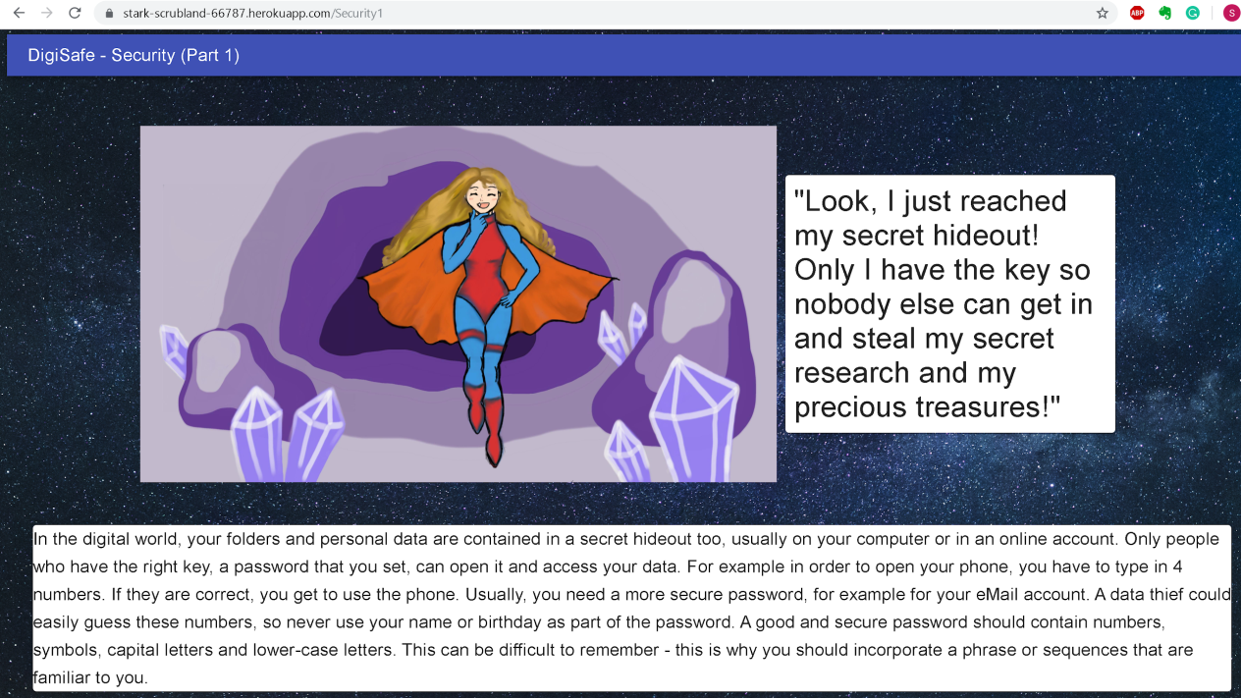

In order to continue to the question, the child has to scroll down and click on the continue button on the bottom right. This ensure that the child had sufficient time to read and take in the information at its own pace.



The next page opens where the avatar is giving a relatable explanation how to handle the problem. The facial expression changed, making the game more natural and appealing to children.

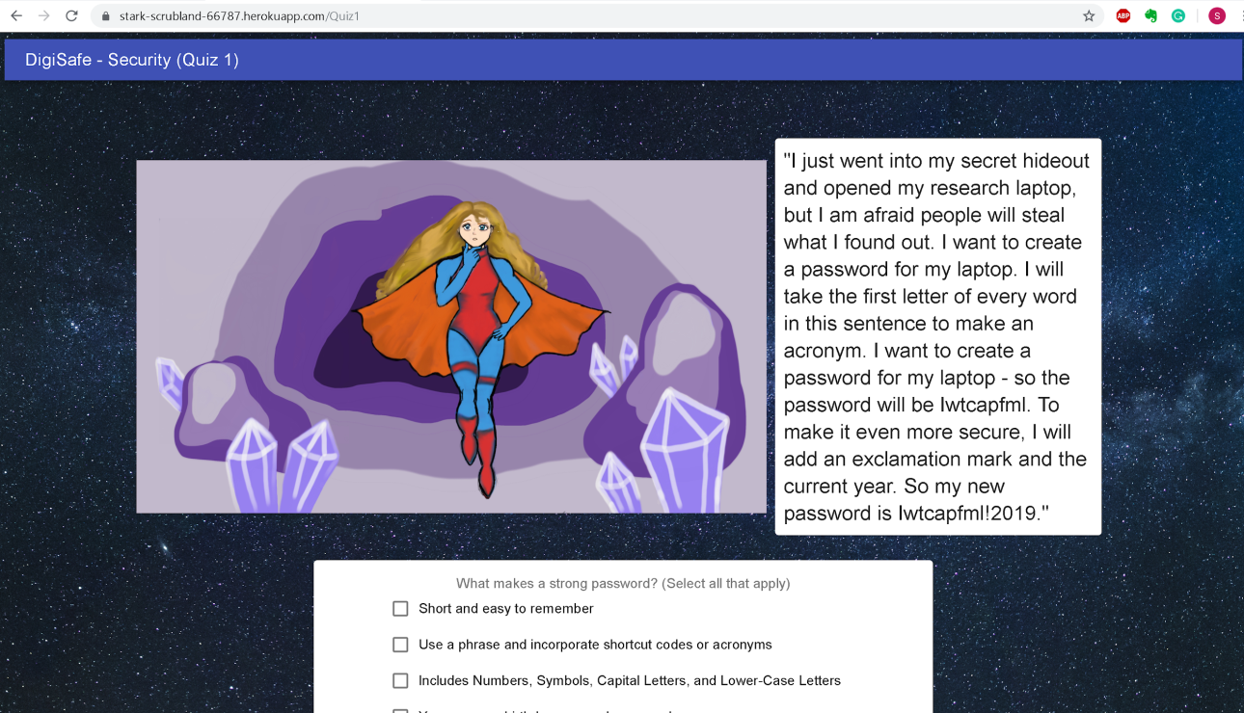

The child then proceeds to answer the multiple-choice, whereas the teacher circles through the room to assist if there are problems or uncertainties if applicable. Clicking on a box on the left of a possible answer box selects the answer. By clicking on submit the game generates the feedback.

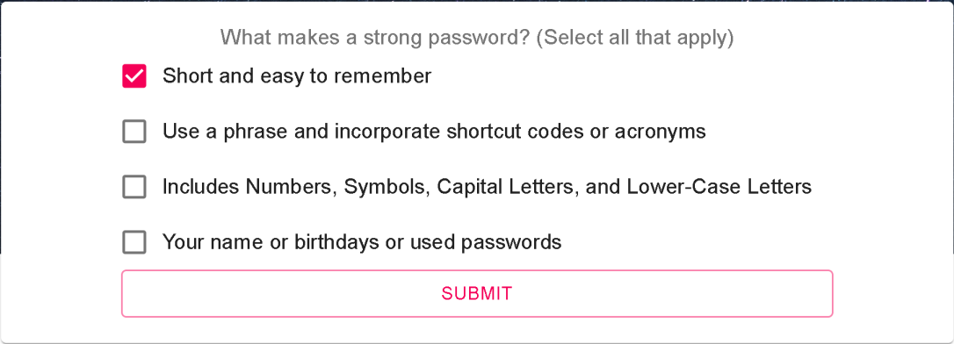

Since the selected answer is incorrect, a pop-up window gives the explanation of why and by clicking on continue, the child can try again until it gets the answer right. 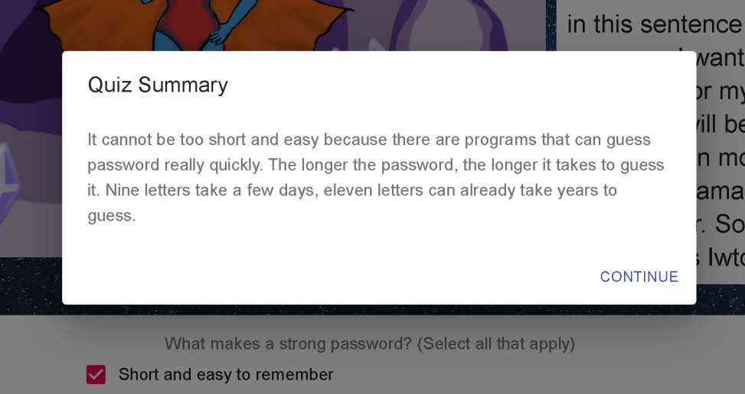

A correct answer triggers the following pop-up window and clicking on continue takes the child to the next question in line.

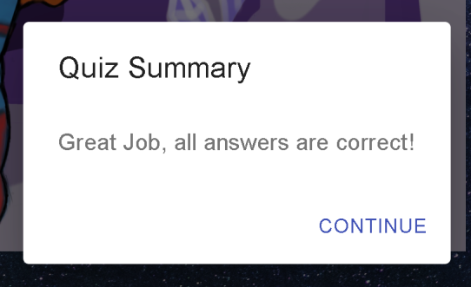

Completing all the questions of the lesson generates this pop-up window. Now, the child can go back to the avatar selection or lesson selection page.

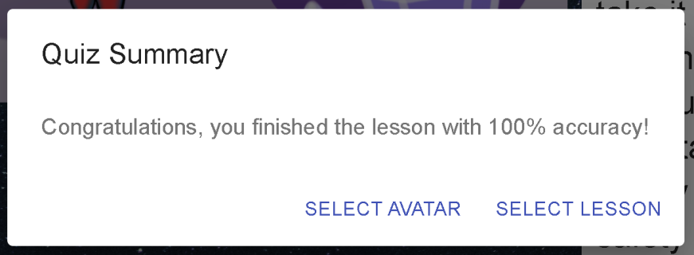

# **6 References**

1. Barrington, Michelle: Literacy Milestones. 7-8 year olds have improved comprehension skills, <https://www.kidspot.com.au/school/preschool/preschool-literacy/literacy-milestones-78/news-story/6ab513fbc41294ec1e328c954aee0d0c>, News Pty, 2019.
2. Biswas, S. and Thakore, D.: Routing with Persistent Link Modeling in Intermittently Connected Wireless Networks. Proceedings of IEEE Military Communication, Atlantic City, October 2005.
3. Chou, Hoelzel, Khanderia, Valenti: Software Project Website. Brief Project Background, <https://beastmodepk.github.io/Project-for-software/WebPage.html>, October 2019
4. Code.org: Nine Policy Ideas to Make Computer Science Fundamental to K–12 Education. <https://code.org/files/Making_CS_Fundamental.pdf>
5. Heitin, Liana:: What Is Digital Literacy? Digital Literacy: An Evolving Definition, <https://www.edweek.org/ew/articles/2016/11/09/what-is-digital-literacy.html>, Education Week
6. Ribble, Mike: Digital Citizenship. *S3 Framework (Safety, Savvy and Social)*, <https://www.digitalcitizenship.net/nine-elements.html>, 2017
7. Scholastic: Leveling Resource Guide. Match students with the right material at the right time, [www.scholastic.com/teachers/articles/teaching-content/leveling-resource-guide/](http://www.scholastic.com/teachers/articles/teaching-content/leveling-resource-guide/), 2019
8. Stuckwisch, Barbara: 9 Lessons To Teach Children About Digital Citizenship. <https://safesitter.org/digital-citizenship/?gclid=EAIaIQobChMIooKR6c-35QIVLYNaBR0wogHrEAAYASAAEgLR3_D_BwE>

# WhatIsMyBrowser.com: What's the latest version of Chrome?, https://www.whatismybrowser.com/guides/the-latest-version/chrome

# **7 Point of Contact**

For further information regarding this document and project, please contact **Professor J. Daly** at University of Massachusetts Lowell (james_daly@uml.edu). All materials in this document have been sanitized for proprietary data. The students and the instructor gratefully acknowledge the participation of our industrial collaborators.